**NoSql**

NoSQL databases (aka "not only SQL") are non-tabular databases and store data differently than relational tables. NoSQL databases come in a variety of types based on their data model. The main types are document, key-value, wide-column, and graph. They provide flexible schemas and scale easily with large amounts of data and high user loads.

When people use the term “NoSQL database,” they typically use it to refer to any non-relational database. Some say the term “NoSQL” stands for “non SQL” while others say it stands for “not only SQL.” Either way, most agree that NoSQL databases are databases that store data in a format other than relational tables.

Over time, four major [types of NoSQL databases](https://www.mongodb.com/scale/types-of-nosql-databases" \t "https://www.mongodb.com/_target) emerged: document databases, key-value databases, wide-column stores, and graph databases.

* **Document databases** store data in documents similar to JSON (JavaScript Object Notation) objects. Each document contains pairs of fields and values. The values can typically be a variety of types including things like strings, numbers, booleans, arrays, or objects.
* **Key-value databases** are a simpler type of database where each item contains keys and values.
* **Wide-column stores** store data in tables, rows, and dynamic columns.
* **Graph databases** store data in nodes and edges. Nodes typically store information about people, places, and things, while edges store information about the relationships between the nodes.

**MONGO DB**

MongoDB is an open-source document-oriented database. It is used to store a larger amount of data and also allows you to work with that data. MongoDB is not based on the table-like relational database structure but provides an altogether different mechanism for storage and retrieval of data, that’s why known as NoSQL database.

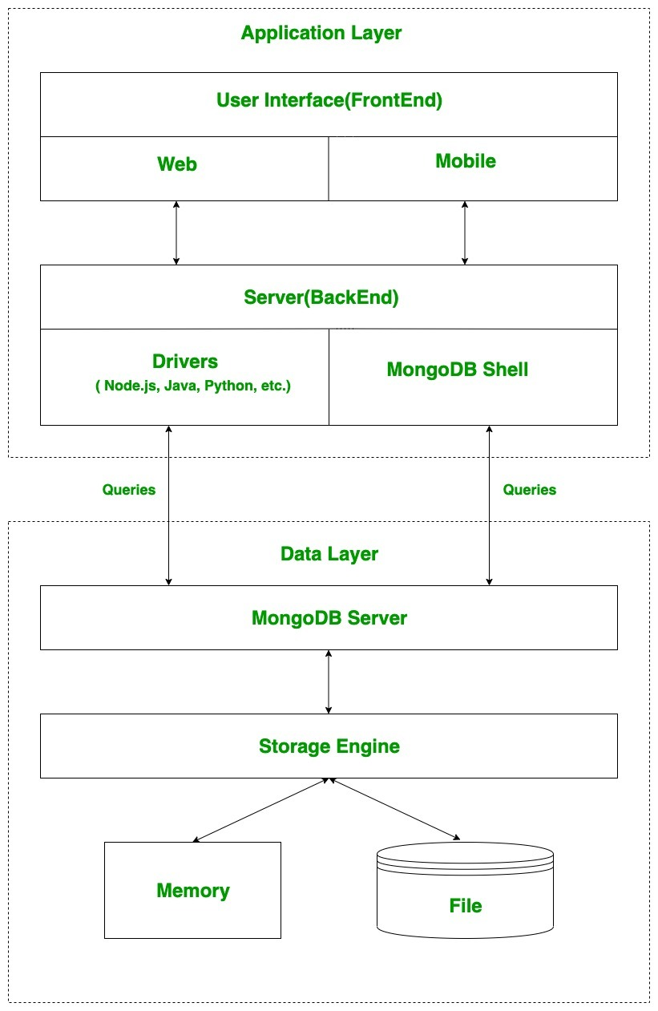

**Install MongoDB on Windows**

To install MongoDB on Windows, first download the latest release of MongoDB from http://www.mongodb.org/downloads.To get your Windows version, open command prompt and execute the following command.

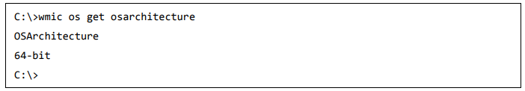

Now extract your downloaded file to c:\ drive or any other location. Make sure the name of the extracted folder is mongodb-win32-i386-[version] or mongodb-win32-x86_64-[version]. Next, open the command prompt and run the following command.

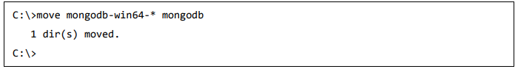

In case you have extracted the MongoDB at different location, then go to that path by using command cd FOLDER/DIR and now run the above given process.

MongoDB requires a data folder to store its files. The default location for the MongoDB data directory is c:\data\db. Execute the following command sequence.



If you have to install the MongoDB at a different location, then you need to specify an alternate path for \data\db by setting the path dbpath in mongod.exe.

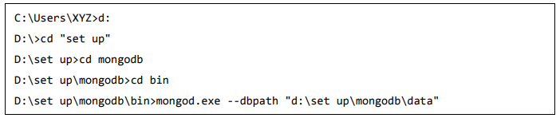

Now to run the MongoDB, you need to open another command prompt and issue the following command.

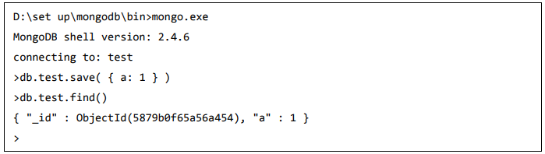

This will show that MongoDB is installed and run successfully. Next time when you run MongoDB, you need to issue only commands.

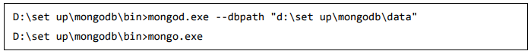

**The insert() Method**

To insert data into MongoDB collection, you need to use MongoDB's **insert()** or **save()** method.

Syntax

The basic syntax of **insert()** command is as follows −

### >db. COLLECTION_NAME.insert(document).

### Eg:

### 

## The Update () Method

The update() method updates the values in the existing document.

### Syntax

The basic syntax of **update ()** method is as follows −

### >db. COLLECTION_NAME.update(SELECTION_CRITERIA, UPDATED_DATA)

### Eg:

### 

**The remove () Method**

MongoDB's **remove ()** method is used to remove a document from the collection. remove() method accepts two parameters. One is deletion criteria and second is justOne flag.

* **deletion criteria** − (Optional) deletion criteria according to documents will be removed.
* **justOne** − (Optional) if set to true or 1, then remove only one document.

### Syntax

Basic syntax of **remove ()** method is as follows –

### >db. COLLECTION_NAME.remove(DELLETION_CRITTERIA)

### Eg:

### 

## Insert multiple documents with Bulk

### It can be used to perform multiple write operations in bulk.

## Initialize a bulk operation builder

First initialize a bulk operation builder for the collection.

* var bulk = db. COLLECTION_NAME.initializeUnorderedBulkOp();

**Eg:**

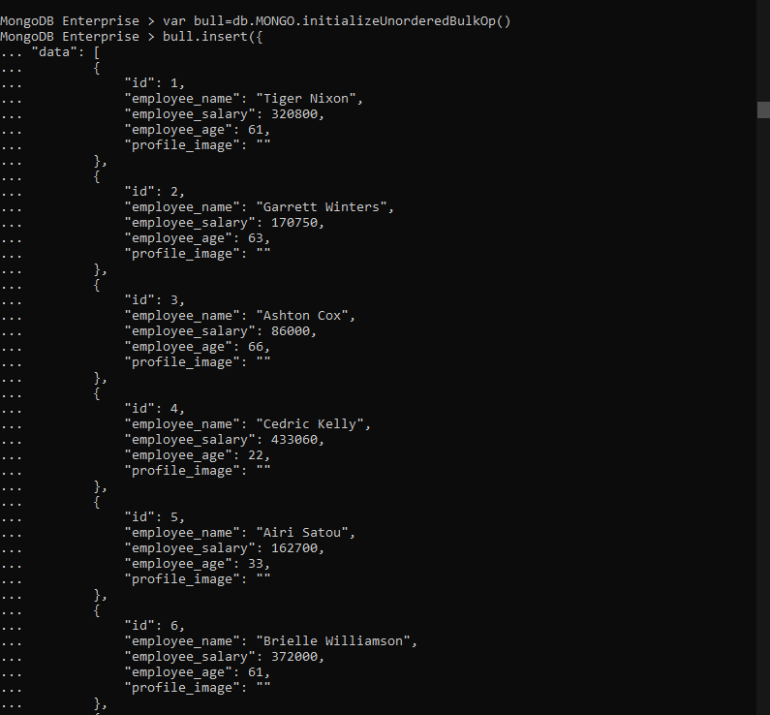

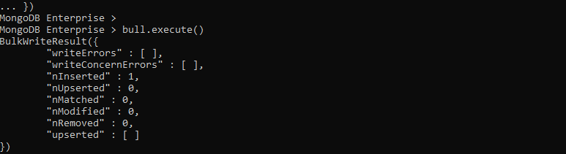

**The Find () Method**

MongoDB's find () method, when you execute find () method, then it displays all fields of a document. To limit this, you need to set a list of fields with value 1 or 0. 1 is used to show the field while 0 is used to hide the fields.

Syntax

The basic syntax of find () method with projection is as follows −

**>db. COLLECTION_NAME.find({}, {KEY:1})**

**Eg:**

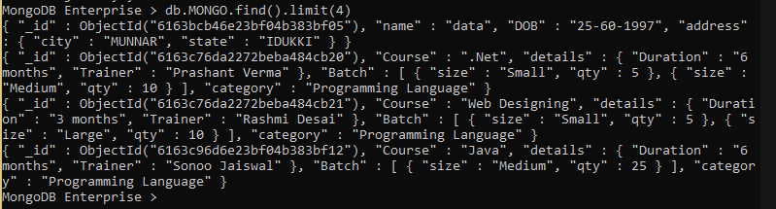

## The sort () Method

To sort documents in MongoDB, you need to use **sort ()** method. The method accepts a document containing a list of fields along with their sorting order. To specify sorting order 1 and -1 are used. 1 is used for ascending order while -1 is used for descending order.

### Syntax

The basic syntax of **sort ()** method is as follows −

### >db. COLLECTION_NAME.find(). sort ({KEY:1})

### Eg:

### 

**The aggregate () Method**

For the aggregation in MongoDB, you should use aggregate () method.

Syntax

Basic syntax of aggregate () method is as follows −

**>db. COLLECTION_NAME.aggregate(AGGREGATE_OPERATION)**

### ****$match****

### **The $match stage can use an index to filter documents if it occurs at the beginning of a pipeline.**

### ****$sort****

### **The $sort stage can use an index as long as it is not preceded by a $project, $unwind, or $group stage.**

### ****$group****

### **The $group stage can sometimes use an index to find the first document in each group if all of the following criteria are met:**

### **The $group stage is preceded by a $sort stage that sorts the field to group by,**

### **There is an index on the grouped field which matches the sort order and**

### **The only accumulator used in the $group stage is $first.**

### ****Eg for $match:****

### 

**Eg for $group:**

